**EXPERIMENT-2**

**Aim-** To create Docker volume and attach it with Containers for persistent storage.

**Procedure:**

**1)** First verify if Docker is installed in your system. To check run command **docker --version**.  
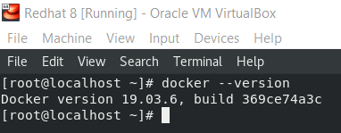

**2)** To create persistent volume in Docker, use command **docker volume create <volume-name>**. After creating volume we can see all the Docker volumes with the help of command **docker volume ls**.

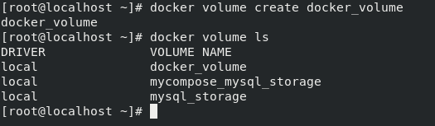

**3)** Now while launching container use option **-v** to attach volume to any directory inside the container. Inside the container, store any file or data in the directory attached to volume.  
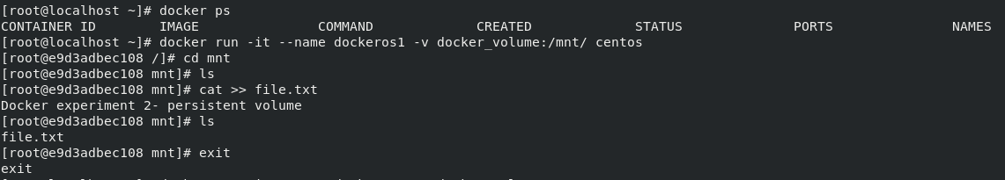

**4)** Now launch another container and attach the same volume with any directory inside the container. Inside the container, we can see same file and data that we stored on another container.  
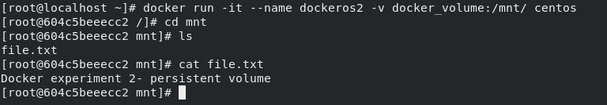

**5)** Use command **docker inspect <volume-name>** to see all details about the volume.  
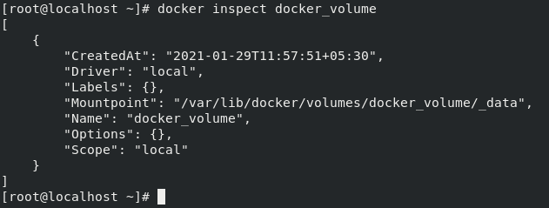

**Submitted by:**Ajay Kumar Tyagi  
500067403  
R171218008  
CSE-DevOps 2018-2022